**Palm Harbor University High School**

**Second Semester Exam Information**

**2022-2023**

Final examinations for first semester of the 2022-2023 school year, will begin on **Monday,**

**December 19, 2022** for all students.

**Monday, December 19, 2022** 1st Period Exam 7:25 – 10:22

Lunch 10:22- 10:52

2nd Period Exam 10:58 – 1:55

**Tuesday, December 20, 2022**  3rd Period Exam 7:25 - 10:22

Lunch 10:22 -10:52

4th Period exam 10:58 -1:55

**Wednesday, December 21, 2022** 5th Period Exam 7:25 - 10:22

Lunch 10:22 -10:52

6th Period exam 10:58 -1:55

**Thursday, December 22, 2022**  7th Period exam 7:25 – 9:40

**\*Please follow the attached schedule for 12/22/2022**

Each exam shall be a minimum of one hour forty-five minutes. The remaining 1 hour and 20 minutes shall be used to collect books, any last-minute housekeeping chores, and to answer last minute questions (review). All teachers giving exams shall be expected to plan for a review time prior to the exam day.

**\*Please note:** Please ensure the amount of time allotted for each exam is consistent between all classes. The amount of time that is allowed for the 1st period exam should be consistent for all exams.

Teachers will hold a textbook check Friday, **December 16, 2022.**

Teachers should submit a copy of their final exams to their **department chairpersons** by **Friday, December 16, 2022.**

Department chairpersons should submit all copies of exams to Mr. William Klein, registrar by **Friday, December 23, 2022.**

**Exam Policies –** Please review the following information with students concerning final examinations requirements.

* Students are **required to take** the final examination in each course in which the student has a course grade of "C", "D", or "F" in the 1st nine weeks of the term or has a provisional course grade of "C", "D", or "F" for the 2nd nine weeks of the term.

Students who have a course grade of "A" or "B" in the 1st nine weeks of the term and have a **provisional course** grade of "A" or "B" in the 2nd nine weeks of the term can choose to exempt up to 3 exams in the courses that they meet the eligibility for exam exemption.  Students may not exempt the 1st semester final exam if it is an Advance Placement (AP), IB, Advanced International Certificate of Education (AICE) exam, or courses that have an EOC attached to them.

* Students choosing to exempt the exam must maintain the required grade through the remainder of the 2nd nine weeks of the term.
* The provisional 2nd nine weeks grade for the term will be based on the grades earned for the first 7 weeks of the second grading period. Please Inform students of their provisional 2nd nine weeks grade by **Friday, December 2, 2022.**
* A student enrolled in the same course during two terms of the same school year is required to take at least one final exam in that course.
* Students not required to take a final exam may elect to take their final examinations to improve their final grades.  The final course grade shall not be reduced as a result of the examination grade, should the student elect this option.
* If a student is exempt from their exam (has been approved to not to take an exam), he/she will not have an exam grade, please use the **X** option for exempt when recording your grades under the semester 1 exam tab in Portal. These students’ final grades will be the average of the two nine week’s grades. These students may elect to take an exam that they have not been required to take, however these exams **will not count** **toward the student’s final grade** **unless it raises the grade.**
* If a student fails to appear for a semester examination, an “F” needs to be recorded in the semester exam tab and the “F” should be averaged in as the third grade when determining the final grade. A student **does not** automatically fail the course if they do not show for the final exam.
* **EARLY EXAMS**

Please have students who are wanting early exams to see their Administrator.

**Grading Information**

* The chart below shows how the grades are averaged for final semester grades for both EOC classes and non-EOC classes

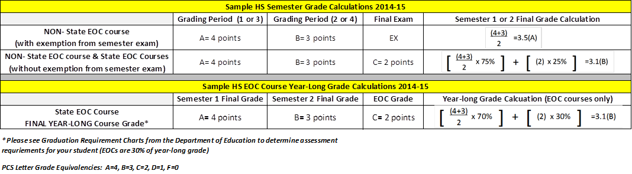

* If the student’s grade point average in a course is 3.5, 2.5, 1.5, or .5 it will be the option of the teacher as to whether the higher or lower grade will be given**. If the lower grade is given, the decision must be documented and approved by the Principal, Mrs. Patterson, or designee, Ms. Berry.**
* Grading Scale: The grading system and interpretation of letter grades used in high school shall be as follows:

A = 4 grade points (90%‑100%) (Outstanding progress)

B = 3 grade points (80%‑89%) (Above average progress)

C = 2 grade points (70%‑79%) (Average progress)

D = 1 grade point (60%‑69%) (Lowest acceptable progress)

F = 0 grade points (0‑59%) (Failure)

I = 0 grade points (Incomplete)

* + Percent between 89% and 90%, 79% and 80%, 69% and 70%, and 59% and 60% must be rounded up to the higher grade if at the midpoint (.5) or above; those below the midpoint (.5) shall be rounded down to the lower grade.
* It is imperative that the attendance record in your grade books and in Portal be identical without exception. Any changes to student attendance in Portal must be submitted to Mrs. Redfield.

**Textbook Information**

* Textbooks will be checked by all teachers on **Friday, December 16, 2022**. All textbook obligations should be registered on “Lost and Damaged Textbook” forms. Department chairs have the forms. All information should be filled out by the teacher, and all forms returned to Mr. Larson by **Friday, December 23, 2022**. Any student prepared to pay for their lost or damaged textbook is to be given a completed obligations form to take directly to the bookkeeper’s office for payment and receipt.
* If a student does not have his/her assigned textbook and does not have the money to pay please record their name and other pertinent information on the Lost Textbook Grade sheet (see attached copy) and give the student an incomplete (“I”) for the final grade. Please record the grade they earned on the Lost Textbook Grade Sheet. Again, please be sure the student has a lost textbook notification card completed by you.

**Student Information**

* After the last exam of the day, all students must exit the campus. Students do not come back into the school without teacher supervision (i.e. athletics).
* All students must take their final exam unless they were granted approval not to take them. Do not send the students away nor discourage him/her from attending the exam session regardless of the grade situation.
* Driver Education Classes - Students enrolled in these classes may not exempt the exam if they are receiving a license through the course.